# Quell AI: Enhancing Collaboration Through Intelligent Absence Assistance

**Proposed AI Meeting Assistant**



Cover image – AI assistant in a virtual meeting

## Introduction

In today’s hybrid‑work environment, professionals juggle multiple projects while attending numerous meetings across time zones. Constant meeting invites can interrupt deep work, and unplanned absences or time‑zone differences make it difficult to maintain continuity. Tools like **Google Meet**, **Microsoft Teams** and **Zoom** now offer AI‑powered features such as automatic recording, live transcription and intelligent recaps that help people catch up on meetings. For example, Google Meet can automatically record and transcribe a meeting and email the transcript to the meeting organizer and co‑hosts [1]; hosts can even configure recording and transcription to start automatically when the meeting begins [2]. Similarly, Microsoft Teams provides *recaps* of recorded or transcribed meetings; a recap contains the event recording, transcript, shared files, notes, agenda and follow‑up tasks [3]. Teams’ *intelligent recap* feature (available through Teams Premium or Microsoft 365 Copilot) generates AI‑powered notes, tasks and timeline markers to help users review key moments [4]. Zoom’s *AI Companion* can summarize meetings, generate reports and even create documents from meeting summaries, ensuring that crucial information is captured and shared.

Despite these advancements, users still face limitations. Existing tools record and summarize meetings, but they do not actively participate on a user’s behalf. Busy developers and team leaders are often pulled into overlapping meetings; if they decline, they must manually ask colleagues for minutes. Emergencies or unplanned leave can leave an entire project without a representative, causing communication gaps. Off‑shore and on‑shore teams may struggle to meet synchronously due to time‑zone differences. Organisations need a solution that not only captures meetings but can **represent a user** when they cannot attend.

## Origin and Vision of Quell AI

**Quell AI** (pronounced *kwell*) began as an internal proposal to address these pain points. The idea emerged from observing overworked team members who either attended multiple overlapping meetings or missed important discussions entirely. Traditional meeting tools could record and transcribe, but there was no agent to **speak on behalf of the absent user**, provide relevant answers or enforce data‑access restrictions.

The vision for Quell AI is to create a **context‑aware meeting agent** that can join virtual meetings when you cannot, interact with participants, provide data‑driven answers, record and summarize discussions, and deliver actionable outcomes all while respecting the user’s privacy and access policies. Quell AI combines elements of existing technologies (natural‑language understanding, retrieval‑augmented generation (RAG) models, automatic speech recognition, meeting scheduling and Active Directory integration) into a unified service.

## Challenges of Modern Collaboration

* **Meeting overload** – Developers or team leaders often receive multiple meeting invites, making it hard to focus on deep work. If they decline, they need to email colleagues requesting minutes, which delays progress.
* **Unplanned absences** – Personal emergencies or sudden sick leave can make an employee unreachable. Without a representative, the team may postpone decisions or proceed without input, risking misalignment.
* **Time‑zone disparities** – Off‑shore and on‑shore teams may not share working hours. Critical discussions can occur when key stakeholders are asleep, leading to communication gaps.
* **Limited AI participation** – Tools like Google Meet and Microsoft Teams provide transcripts and summaries but do not engage on a user’s behalf. They cannot answer questions or share files from the absent user’s context.

## Existing Solutions and Gaps

| Platform | Key AI‑assisted features | Limitations |
| --- | --- | --- |
| **Google Meet** | Automatic recording and transcription can be enabled; transcripts are saved to the organizer’s Drive and automatically emailed to hosts and co‑hosts after the meeting [1]. Hosts can enable recording, transcription and note‑taking to start automatically when a meeting begins [2]. | Transcription provides a record of what was said but does not represent absent participants or answer questions. |
| **Microsoft Teams** | Recap pages include the recording, transcript, shared files, notes, agenda and follow‑up tasks for any recorded or transcribed event [3]. Intelligent recap (Teams Premium or Copilot) offers AI‑generated notes, tasks and timeline markers; these features personalize the review experience and highlight name mentions and timeline markers [4]. | Recap is available only after the meeting ends and does not allow the AI to answer questions on the user’s behalf. Access to intelligent recap is limited to certain licenses. |
| **Zoom AI Companion** | Generates meeting summaries, action items and documents; can transform meeting summaries into ready‑made documents for further editing [5]. Provides chat and channel summaries and highlights key points [6]. | Focuses on summarization and document creation; does not proactively attend meetings or restrict data sharing to specific groups. |

These tools focus on *post‑meeting* artifacts (summaries, transcripts), leaving a gap for real‑time representation and interaction.

## Concept and Architecture of Quell AI

Quell AI acts as an **intelligent meeting delegate** that can be activated when the user is unavailable or chooses to be represented by an AI agent. The agent is **permission‑controlled**: users decide which files and knowledge bases it may access and specify which participants it may share information with. Integration with **Active Directory** (AD) and group policies ensures that data sharing adheres to organisational rules and confidentiality requirements.

### Key Components

* **User Control & Permissions** – Prior to a meeting, the user configures Quell AI’s access. They can point the agent to specific folders or documents (for example, project specifications or design docs) and limit who the agent can share information with (e.g., only the project team). AD groups enforce these restrictions.
* **Context Ingestion and RAG** – Quell AI uses retrieval‑augmented generation (RAG) to combine the meeting transcript with contextual data (such as the user’s files and prior communications). The agent indexes the permitted documents and uses them to answer questions accurately.
* **Meeting Participation** – When a meeting starts, Quell AI joins as a participant. It listens to conversations, identifies questions directed at the absent user and uses the ingested context to respond in natural language ideally in the user’s voice tone and style. The agent also logs questions it cannot answer and flags them for the user.
* **Recording, Transcription and Summarization** – Like existing tools, Quell AI records the meeting and generates a transcript. It synthesizes key points, decisions and action items into a concise **minutes of meeting** document and distributes it to the user and authorized participants.
* **Post‑Meeting Analytics** – Quell AI produces follow‑up tasks, deadlines and owners. It may integrate with project management tools to update tasks automatically. The user reviews the outputs, corrects any errors and sends confirmations.

### 

### Workflow Overview

The flowchart below illustrates the typical Quell AI workflow from scheduling a meeting to post‑meeting review.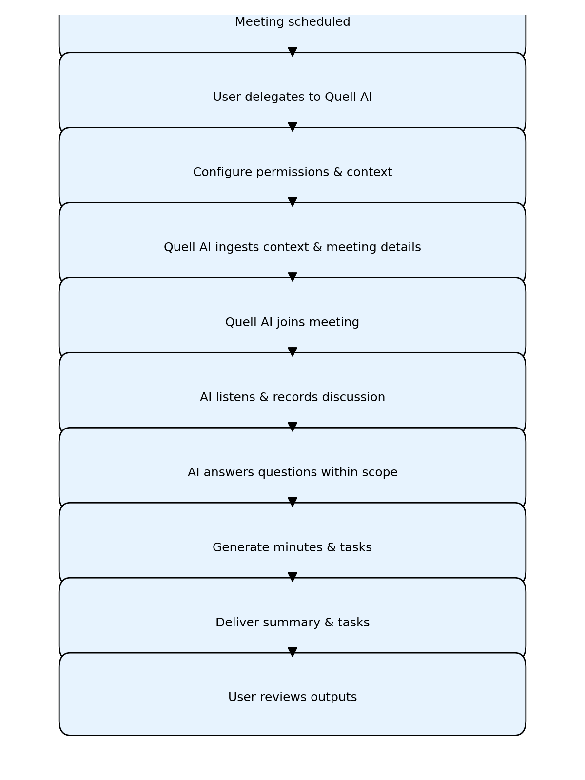

Flowchart of Quell AI workflow

1. **Meeting scheduled** – A meeting invite arrives via the calendar.
2. **User delegates to Quell AI** – The user can accept the invite and indicate that Quell AI will represent them.
3. **Configure permissions & context** – In a pre‑meeting dashboard, the user authorizes specific files, notes and data sources and sets restrictions on who the agent may share information with.
4. **Context ingestion** – Quell AI indexes the selected data and fetches meeting details (agenda, participants).
5. **Quell AI joins meeting** – At the meeting time, Quell AI joins, listens and records the conversation.
6. **Listen & respond** – The agent transcribes the discussion and answers questions within its permissions.
7. **Generate minutes & tasks** – After the meeting, Quell AI compiles the transcript and generates minutes, action items and tasks.
8. **Deliver summary** – The agent distributes the summarized minutes and tasks to the user and authorized participants.
9. **User review** – The user reviews the outputs, approves or adjusts tasks, and follows up as needed.

### High‑Level System Architecture

A simplified architecture diagram (not shown here) would include the following layers:

1. **User & Interface Layer** – Calendar plugin or dashboard where users schedule meetings, delegate to Quell AI and configure settings.
2. **Access Control & Policy Layer** – Integrates with AD to enforce file permissions and group‑level sharing restrictions.
3. **Contextual Knowledge Base** – Indexes user‑approved documents and prior communications using vector embeddings for efficient retrieval.
4. **Conversation Engine** – Handles speech‑to‑text, natural‑language understanding and real‑time response generation. It leverages the RAG engine to incorporate contextual data.
5. **Recording & Summarization** – Captures audio/video, transcribes speech and generates structured summaries, action items and tasks.
6. **Integration Services** – Connects with email, chat, project management and storage platforms to disseminate meeting notes and update tasks.

## Values and Benefits

* **Improved Productivity** – By representing users in meetings, Quell AI frees them to focus on deep work without missing critical decisions. Users no longer need to juggle overlapping meetings or write catch‑up emails.
* **Comprehensive Record Keeping** – The agent records and transcribes meetings, generating minutes and action items similar to how Google Meet automatically sends transcripts [1] or Microsoft Teams provides recaps [3]. However, Quell AI extends this by creating a single source of truth tailored to the user’s needs.
* **Cross‑Time‑Zone Collaboration** – Teams across continents can hold meetings at convenient times. Quell AI ensures absent members still have their voices heard and receive accurate summaries.
* **Reduced Meeting Fatigue** – Leaders and developers avoid being pulled into every meeting; they can review concise recaps later. Intelligent recap features from tools like Teams Premium highlight the importance of summarization [4], and Quell AI builds on this concept.
* **Real‑Time Decision Support** – By answering questions during meetings based on authorized documents, Quell AI helps teams make informed decisions without waiting for a human reply.
* **Security and Compliance** – Integration with AD ensures that Quell AI shares information only with approved groups and does not leak sensitive data. AI‑generated content may contain inaccuracies [4], so user review is mandatory, preserving human oversight.

## Use Cases

1. **Developer on Multiple Projects** – An engineer assigned to several projects cannot attend all stand‑up meetings. They delegate some to Quell AI, which provides real‑time updates and action items. The engineer can then focus on coding while staying aligned with team discussions.
2. **Team Leader Administering a Large Team** – A manager receives numerous meeting invites from sub‑teams. Quell AI attends meetings on her behalf, answers routine questions using approved documentation and generates consolidated minutes that highlight cross‑team dependencies.
3. **Global Teams with Time‑Zone Differences** – A project spans the U.S. and Asia. Meetings scheduled in one region occur outside working hours for the other. Quell AI represents absent members, ensuring their concerns are addressed and decisions recorded.
4. **Emergency or Unplanned Leave** – An employee must take sudden leave. They quickly configure Quell AI to cover upcoming meetings, ensuring colleagues still receive expert guidance and maintain project momentum.

## Limitations and Considerations

* **Accuracy of AI Responses** – AI‑generated responses might be incomplete or inaccurate, as Microsoft notes for its intelligent recap [4]. Quell AI mitigates this by restricting its answers to the user‑approved knowledge base and highlighting questions it couldn’t answer.
* **Privacy and Data Governance** – The agent must strictly adhere to organizational policies. Integration with AD and explicit user consent are essential. It should never access or share files beyond the scope defined by the user.
* **Human Oversight** – Final decisions remain with humans. Users should review meeting summaries and task assignments before execution to ensure correctness and context.
* **Adoption and Trust** – Teams must trust the agent to represent them. Transparency in how Quell AI operates, records data and enforces permissions is key to adoption.

## Visual Inspiration

## 

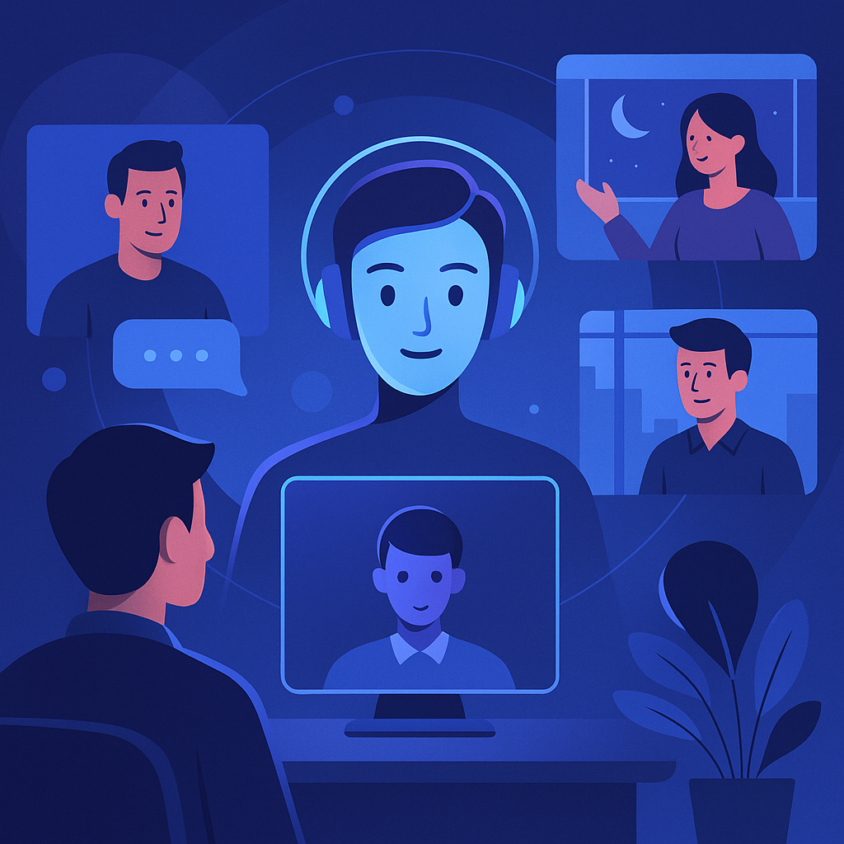

Description -A digital illustration showing a friendly AI avatar representing a user in a virtual meeting. Multiple participants appear on screens, emphasizing remote collaboration and AI presence.

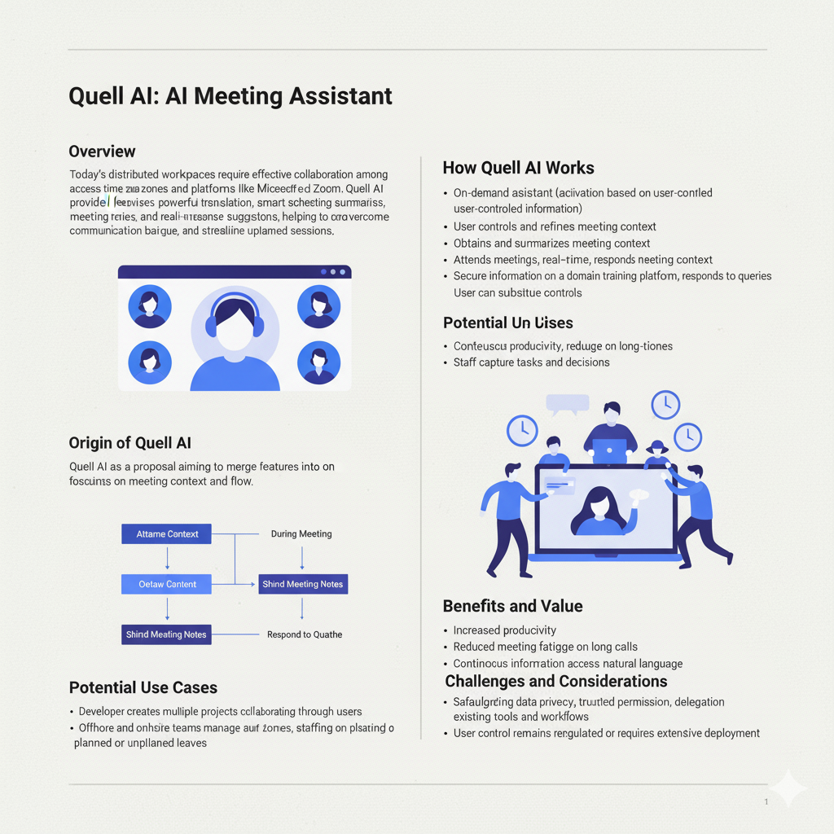



Description -People from different time zones interact via video conferencing, connected by a central AI assistant. A world map and clocks in the background symbolize global collaboration.

## Conclusion and Next Steps

Quell AI proposes an evolution of existing AI meeting tools by acting as a **real‑time delegate** rather than a passive recorder. It leverages advanced AI to join meetings, respond to questions based on user‑authorized data, record discussions and produce actionable minutes. By integrating with Active Directory and enforcing strict permission controls, the agent ensures data privacy while boosting productivity and inclusivity. The concept builds upon existing features like Google Meet’s auto‑transcription [1] and Microsoft Teams’ recaps [3] but fills the critical gap of live representation.

After reviewing this document, organizations can explore building a proof‑of‑concept, refining user interfaces and integrating Quell AI into their meeting workflows. The next steps include detailed design of the conversation engine, integration with existing meeting platforms, and robust privacy and compliance testing.

# References

1. **Google Meet – Use Transcripts** – Meeting transcripts are saved in the organizer’s Drive and automatically emailed to hosts and co‑hosts【38851669365219†L113-L128】.
2. **Google Meet – Automatic recording and transcription** – Hosts can enable recording, transcription and Gemini note‑taking to start automatically when the meeting begins【38851669365219†L131-L139】.
3. **Microsoft Teams – Recap** – Recap pages include the recording, transcript, shared files, notes, agenda and follow‑up tasks for any recorded or transcribed event【851580427850582†L527-L541】.
4. **Microsoft Teams – Intelligent recap** – AI‑generated notes, tasks and timeline markers are available through Teams Premium or Microsoft 365 Copilot, but AI‑generated content may be inaccurate or incomplete【851580427850582†L598-L629】.
5. **Zoom AI Companion – Document generation** – Zoom’s AI Companion can transform meeting summaries into ready‑made documents for editing【296982083566579†L769-L781】.
6. **Zoom AI Companion – Chat summarization** – The AI Companion summarizes chat channels and highlights important information【296982083566579†L796-L810】.